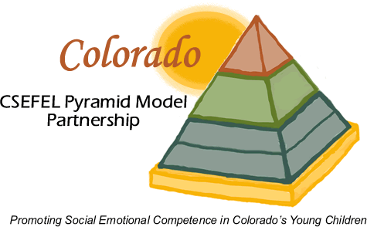

Colorado/CSEFEL Pyramid Model Partnership: Overall Action Plan

Date January 18, 2008
Goal: To promote the social and emotional development of children, birth-five years, through a collaborative professional development system that fosters and sustains the state-wide, high-fidelity use of the Pyramid Model integrated with other relevant Colorado efforts.

Team Darcy, Holly, Linda, Penny, Claudia, Sarah, Laurie, Rosemarie, Tom, Kathleen, Ardith, Barbara D.; CSEFEL staff: Barbara, Phil;

Objectives and Action Steps | Team Coordinator(s) | Resources Needed | Timelines/Status/Date Completed
- Pyramid Model Train the Trainers  - Plan future train the trainers events  - Evaluations indicate training is valued  - Follow-up evaluations indicate training is effective (trainers train on Pyramid Model and practices) |  |  | Spring 2006 140 people trained and evaluations indicate training highly valued; Spring 2007 130 people trained and evaluations indicate training highly valued; fall 2007, 80 people trained, evaluations indicate highly valued.  However, follow-up evaluations indicate that  People trained need more support and information in order to provide training and TA.  Completed
- Pyramid Model Coaches  - Determine Coach criteria and selection process  - Coaches provide on-going support to local programs  - CSEFEL staff provide support to coaches  - Evaluation data collected to measure whether Coaches are effective in training on Pyramid Model and practices |  |  | Application and selection process for coaches sent to attendees from last year’s Pyramid training;  13 Coaches selected by team and 4 sessions held with them during Spring 2007 training including training on TPOT; follow up activities and evaluation conducted including Google discussion group set up and used; teleconferences held  Hold Spring Training for coaches 08
- Pyramid Model Demonstration Sites  - Determine selection criteria and process  - Sites nominated and interviewed  - Sites selected  - Evaluation data collected to measure whether sites implement Pyramid Model and practices effectively; child outcome data collected |  |  | Team and CSEFEL staff determined selection criteria and process; Team nominated possible sites; Team members made initial contact; interviewed; sites selected
IV. Infrastructure and Sustainability  - Letter of agreement between state agencies on Team and CSEFEL  - Members of Team confirmed  - Team develops action plan  - Team implements action plan  - Evaluation data collected to indicate whether professional development system developed and outcomes of system |  |  | Letter of Agreement signed by Claudia Zundel (MH); Tom Patton (CDE); Rosemarie Allen (CDHS-DCC); Kathleen Stiles (Smart Start OPD); Fred DeCrescentis (CDHS, DDD); Darcy Allen-Young (H.S. Collaboration Office; Lt. Govs. Office) and Mary Louise Hemmeter (CSEFEL); developed Goal and objectives  Developing action plans for each objective: Objective I: Infrastructure; Objective II: Professional Development; Objective III: Public Awareness; Objective IV: Access; Objective V: Colorado as a Leader
V. Evaluation of Train the Trainers; Coaches; Demonstration Sites; Infrastructure & Sustainability |  |  | Train the Trainers:  - Evaluations of CSEFEL training  - Follow-up electronic survey re: use of CSEFEL training and materials, barriers and supports for training  Coaches:  - Training evaluations on site  - Follow-up electronic survey – including question about barriers and supports to providing coaching  - Pre-post TPOT/ITERS or other measure for one classroom/setting  - CSEFEL staff – keep log of supports provided to coaches  - For Demonstration Sites -Coaching log – what types of support have they received from CSEFEL, what support have they provided to sites  Demonstration Sites:  - TPOT/ITERS or other measure on 4-month intervals  - CSEFEL observation of Coach  - Stress and support survey  - Child measures will include SSRS and existing child measures from programs  - Families – depends on program priorities  Infrastructure and Sustainability:  - Action plan  - Implementation of Action Plan (progress toward meeting action goals/objectives; products such as policies, interagency agreements, etc.)  - Meeting minutes  - Meeting evaluation  - Sustainability plan (e.g., policies, resources)  - Institutionalizing the pyramid into professional development (e.g., integrating practices into certification competencies, integrating into higher education programs, etc.)
VI. Stakeholder Involvement |  |  | Hold focus groups with coaches, demonstration sites and EC Councils

